**Azure DevOps CI CD for SPFx**

1. Create a Git hub account (In this example I am using GitHub)
2. Create a repository

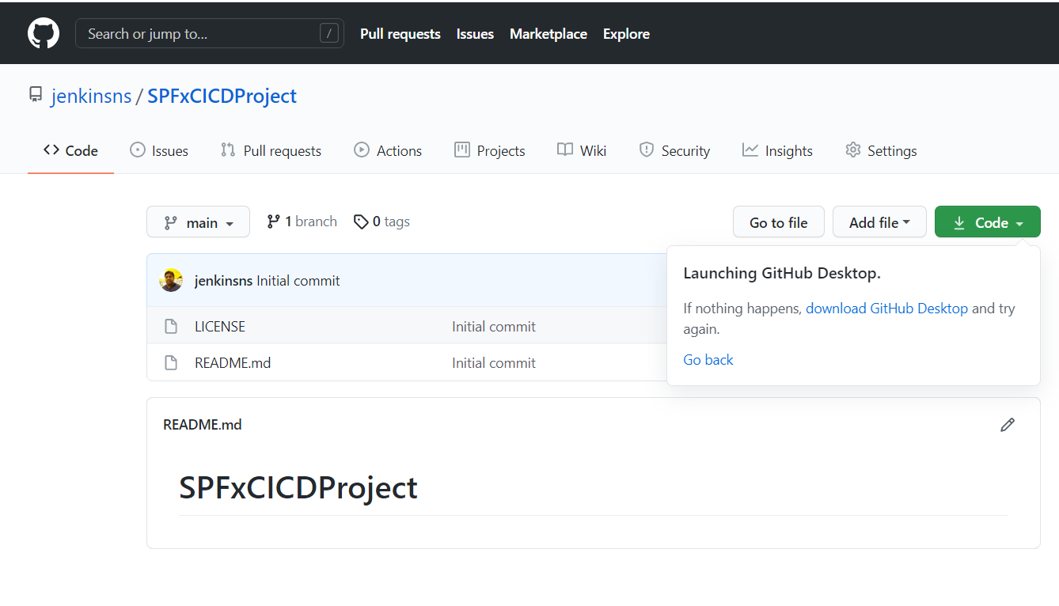

1. Create a SPFx Webpart

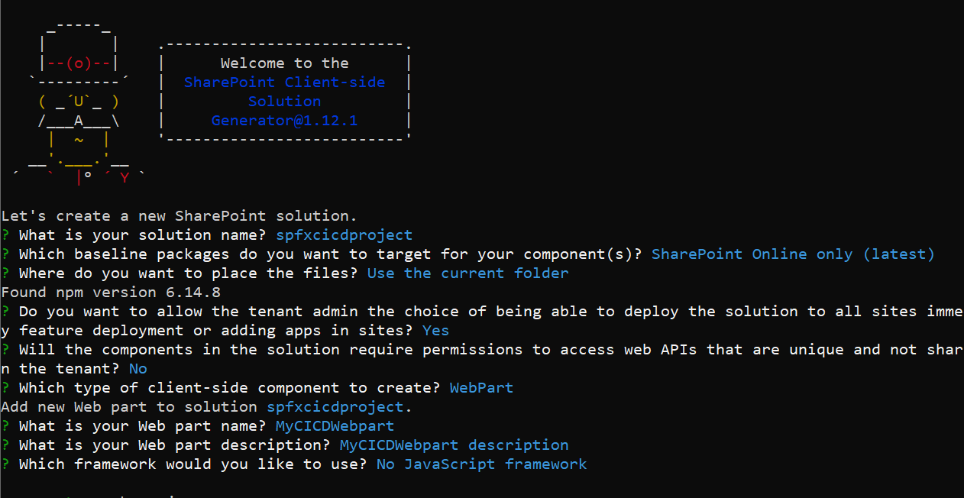

1. Move you Code to Repo
2. Login Azure Devops- <https://devops.azure.com/>

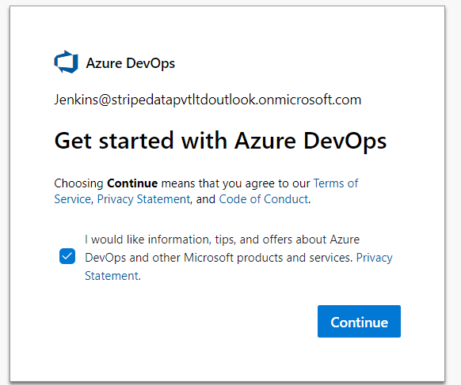

1. First time creating Organization

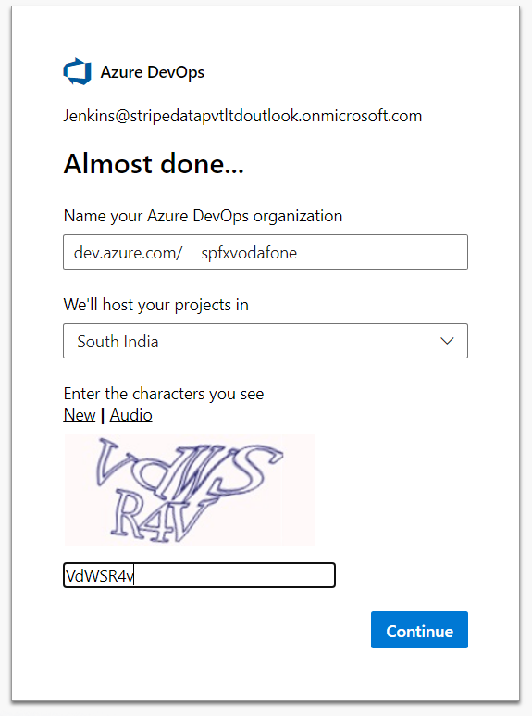

Create new Project

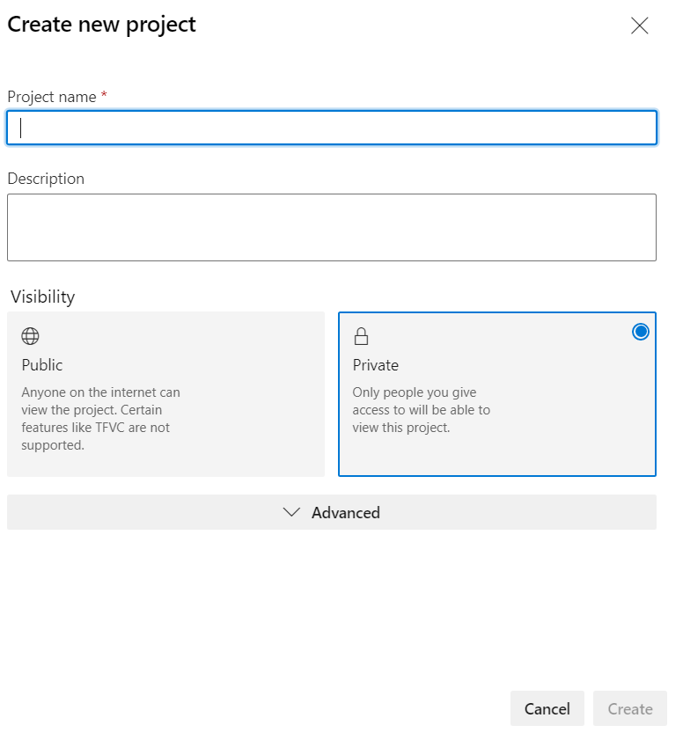

Enter name and Click Create

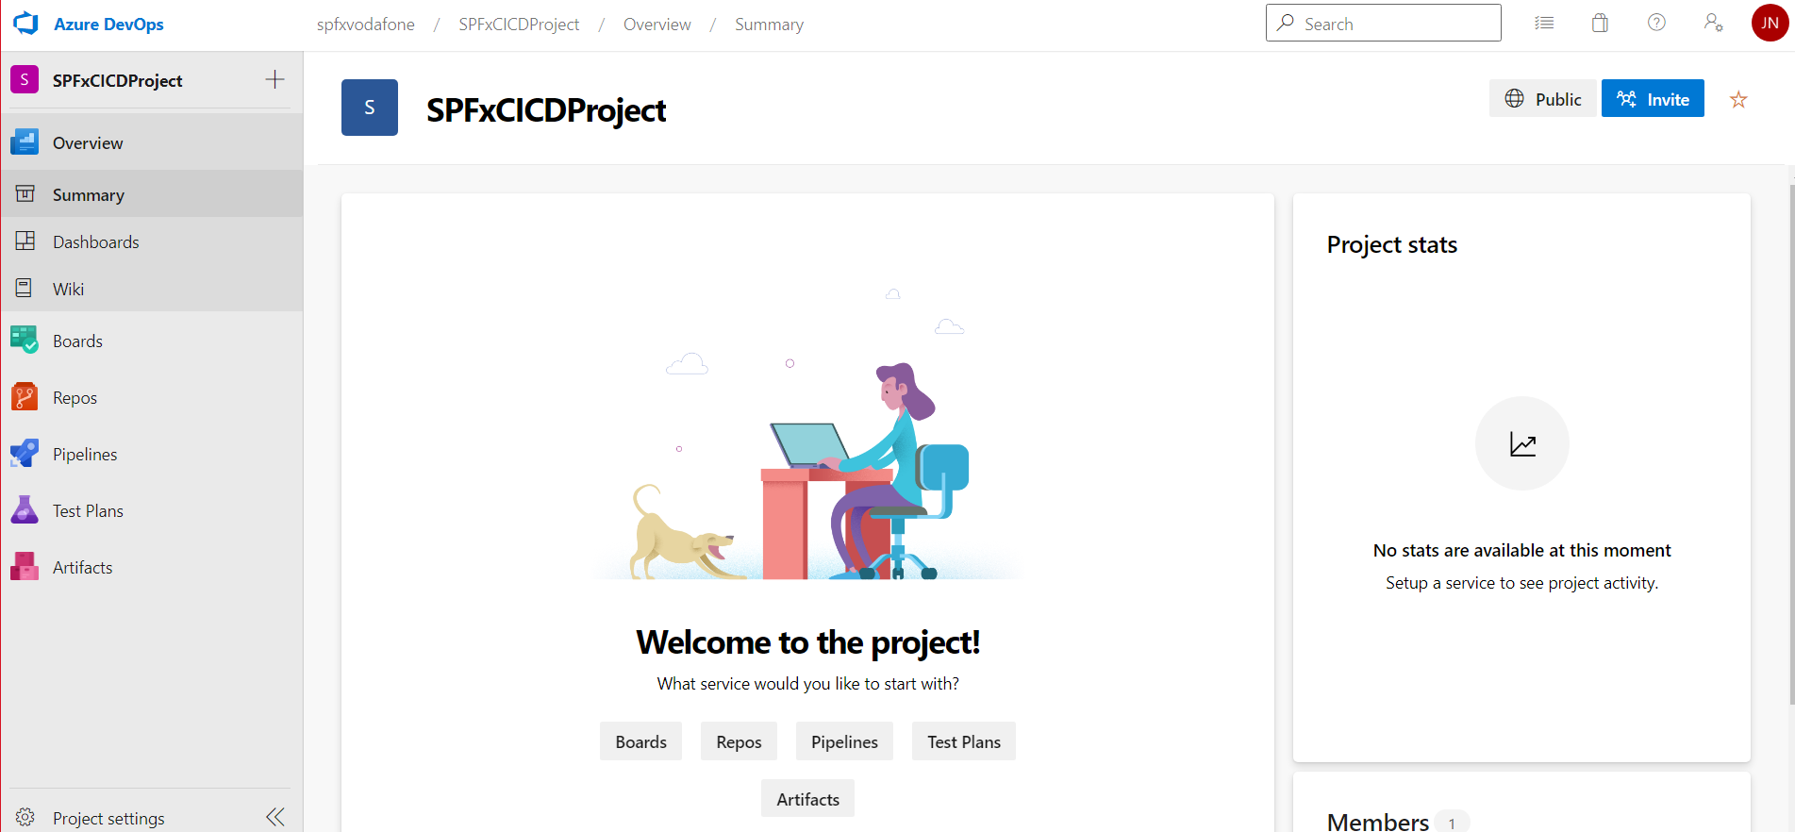

Create Pipeline

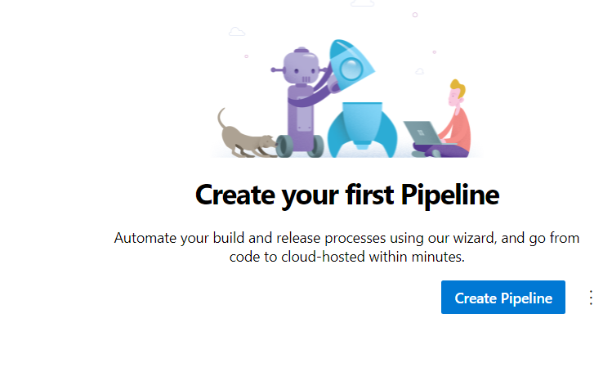

Select use the classic editor

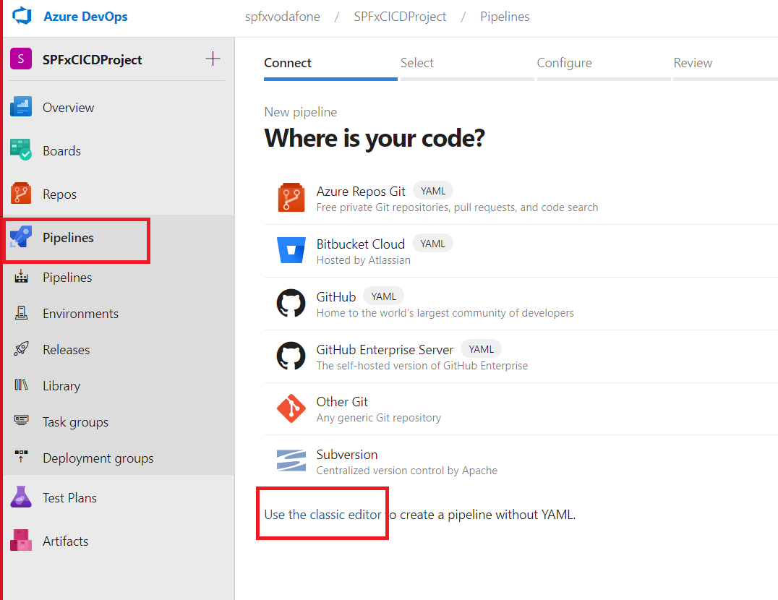

Select a source, where your files avaiable. In this example I am ising Github

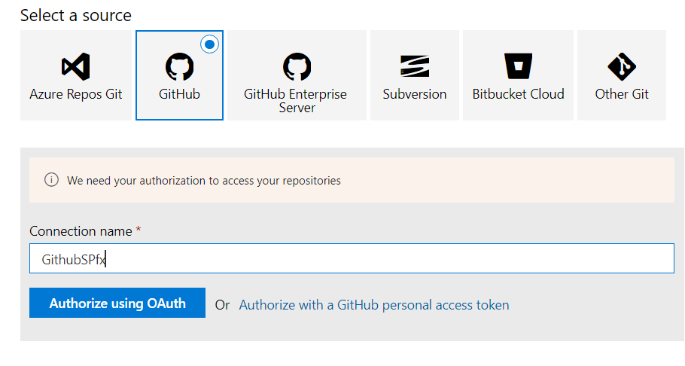

Click Authorize using OAuth and content from Github.

Then select the repository

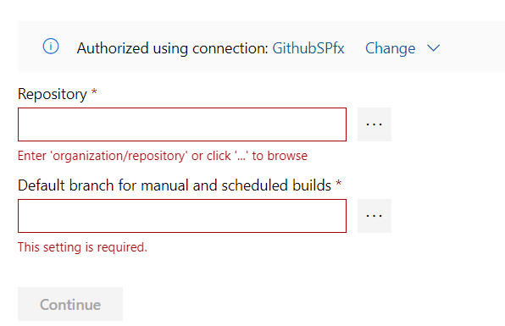

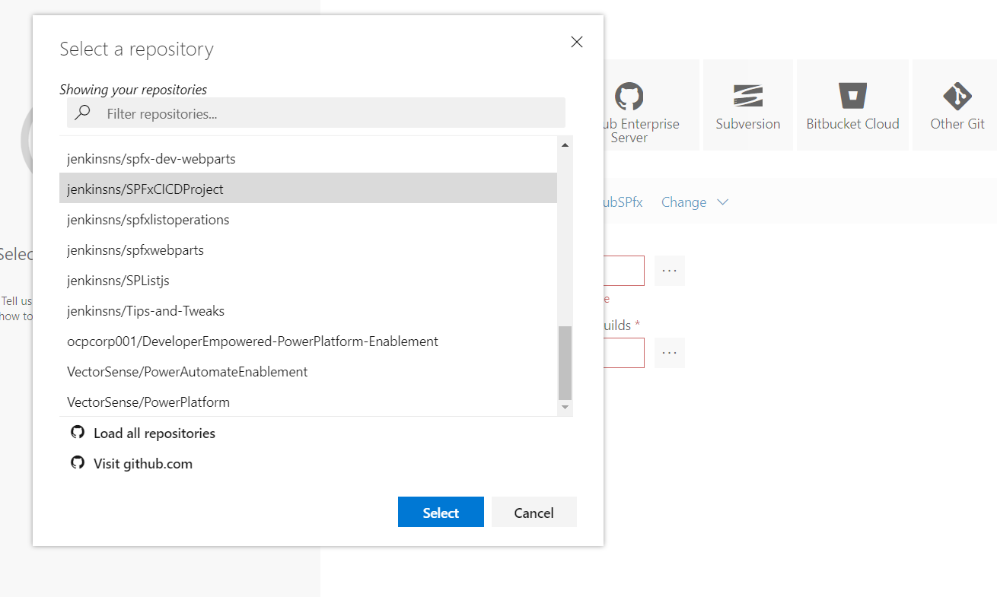

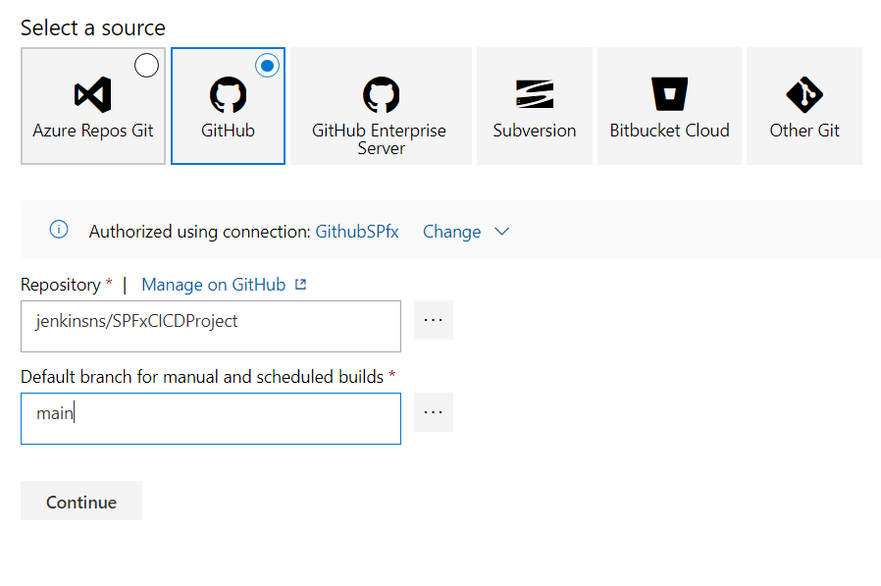

Create new Empty job from pipeline

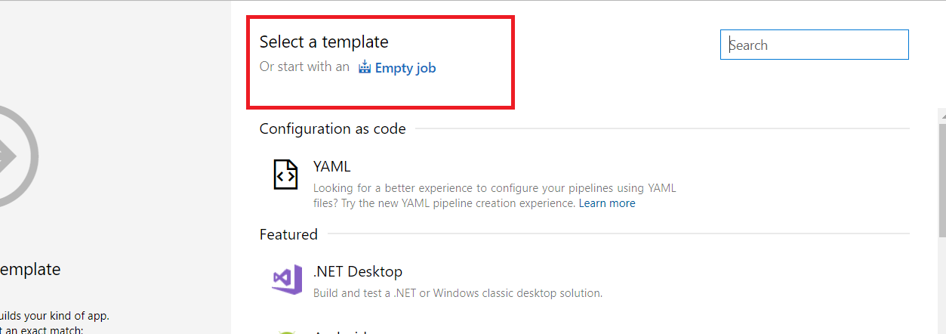

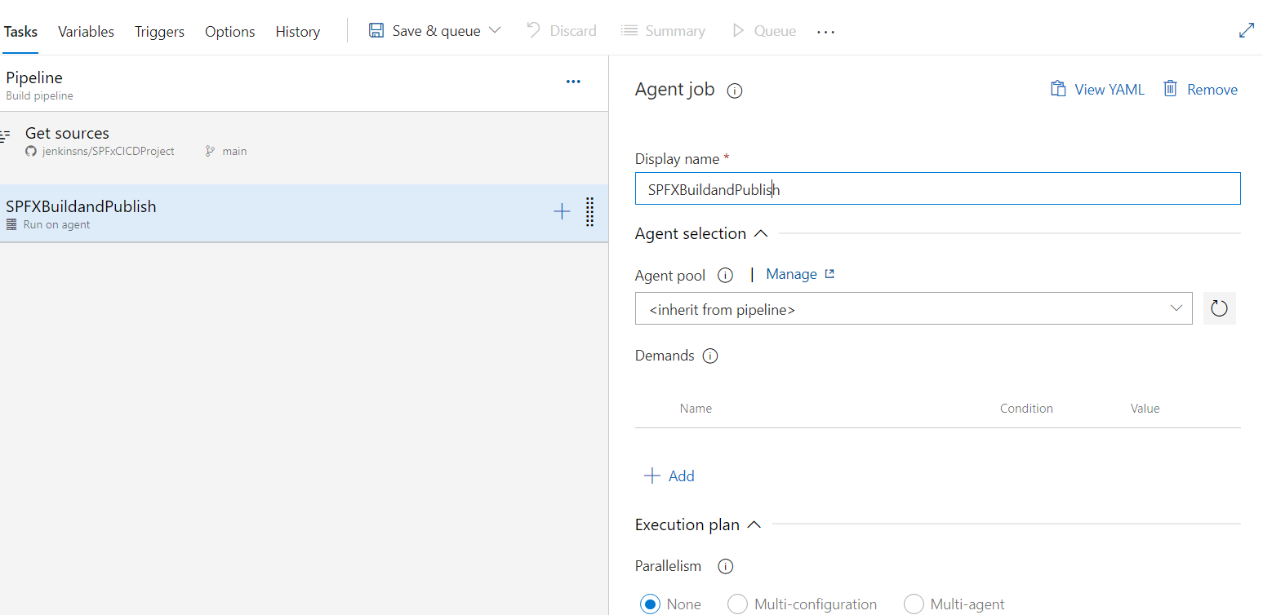

Steps need to add

1. Add Node js

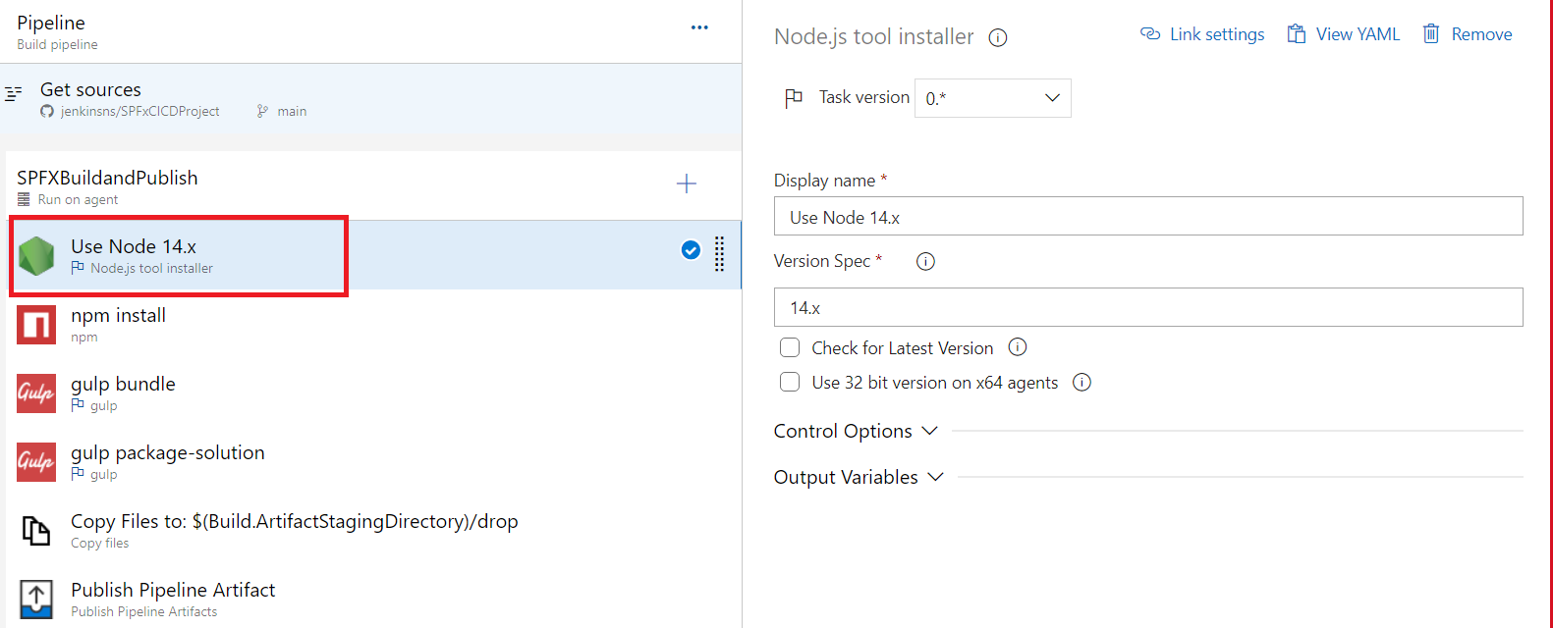

1. Add npm install

*Click plus button and search npm to add*

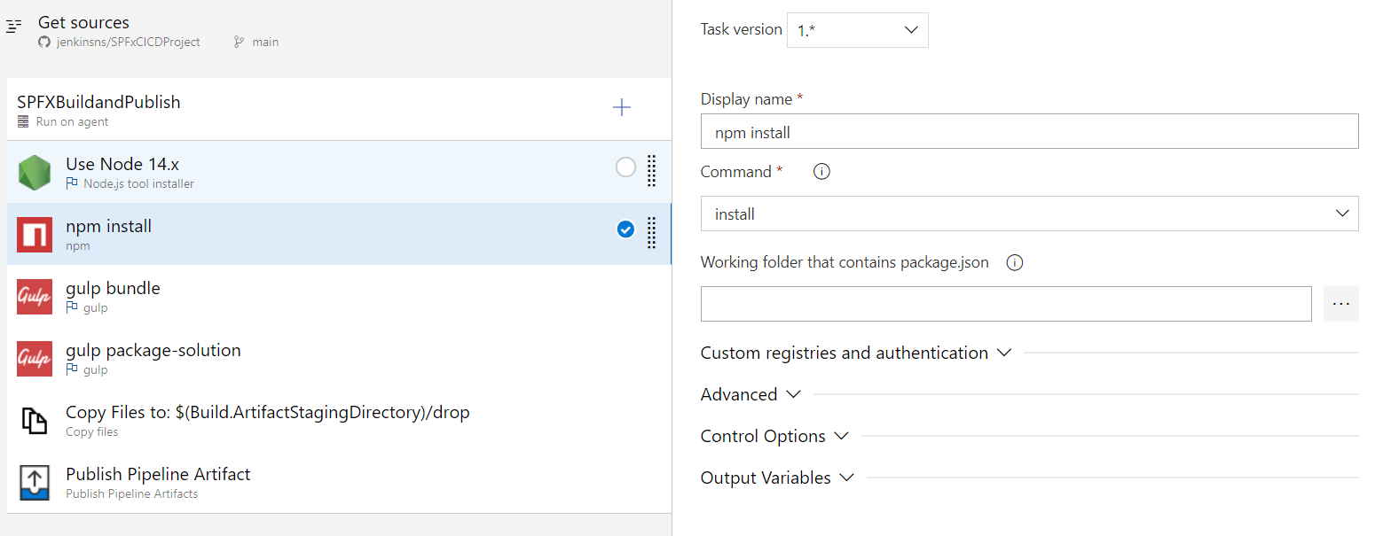

1. gulp bundle –ship

*Click plus button and search gulp to add*

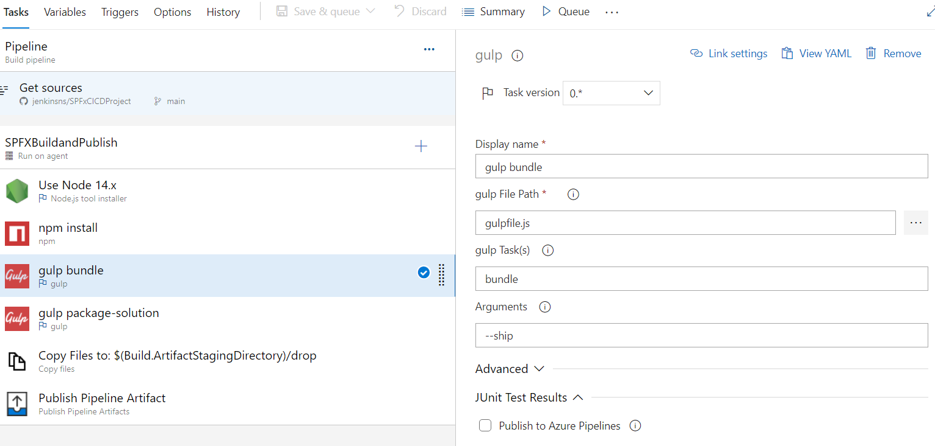

1. gulp package-solution –ship

*Click plus button and search gulp to add*

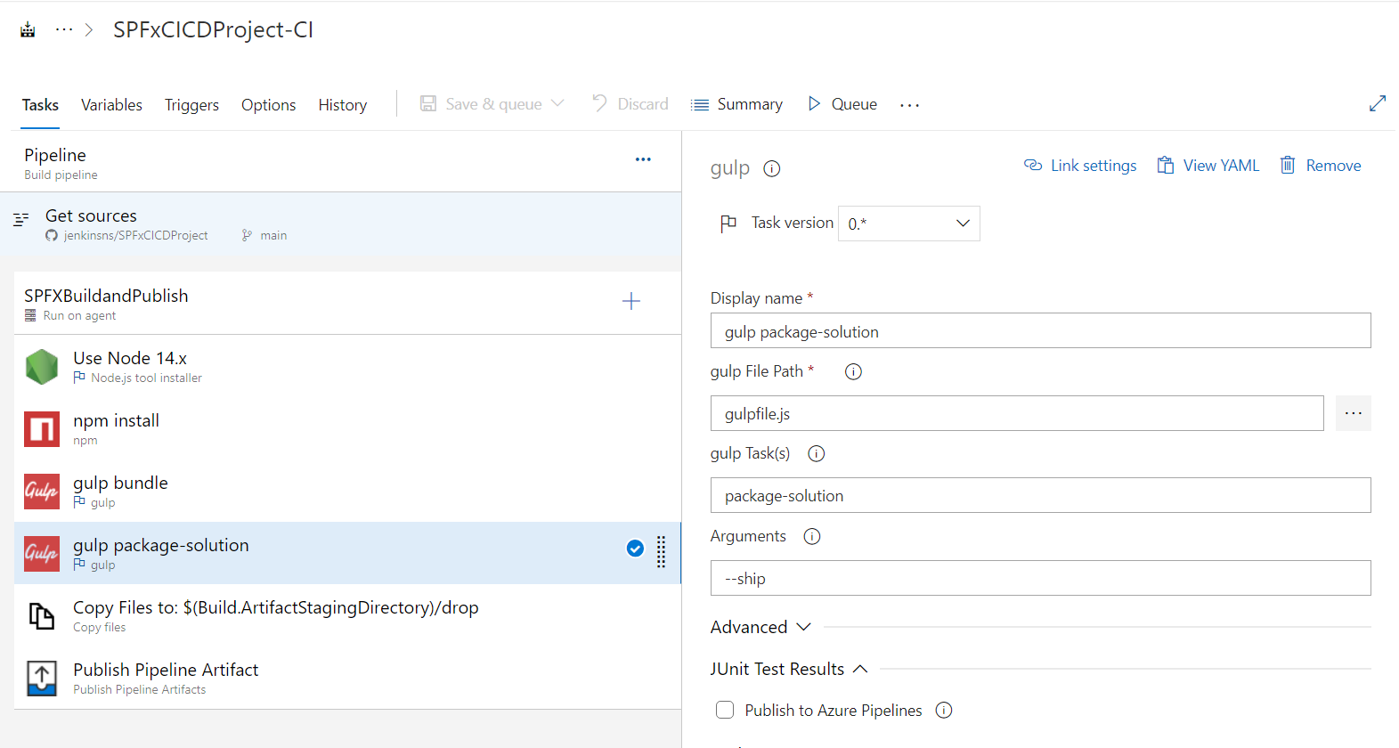

1. copy file

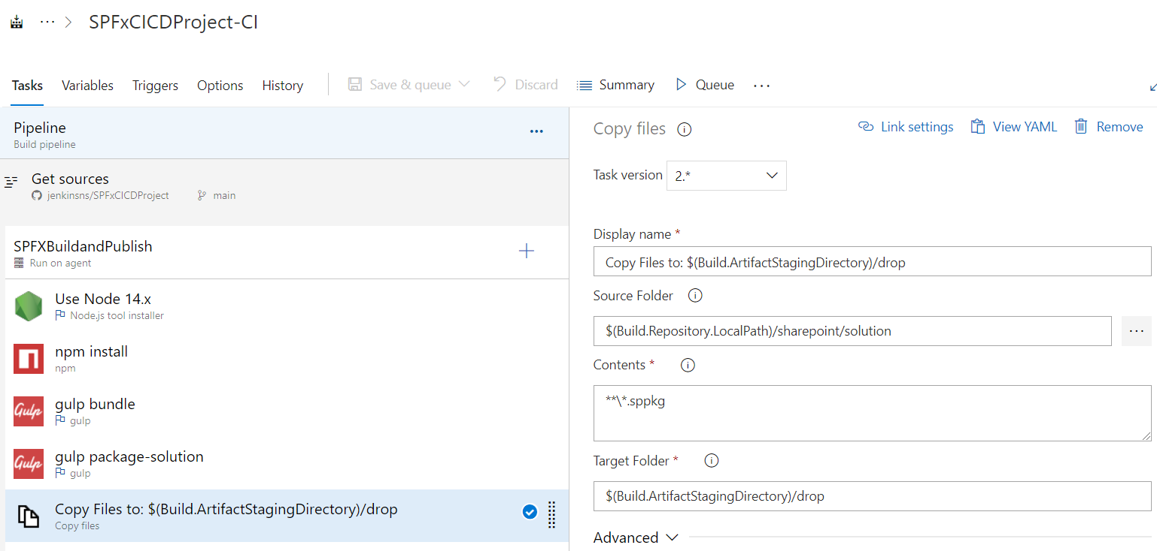

Copy Files to: $(Build.ArtifactStagingDirectory)/drop

$(Build.Repository.LocalPath)/sharepoint/solution

**\*.sppkg

$(Build.ArtifactStagingDirectory)/drop

1. Publish the Pipeline

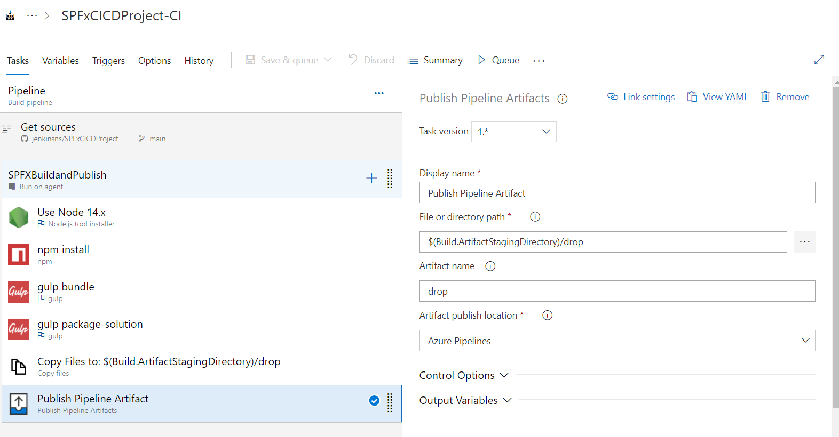

Save it

Go Release

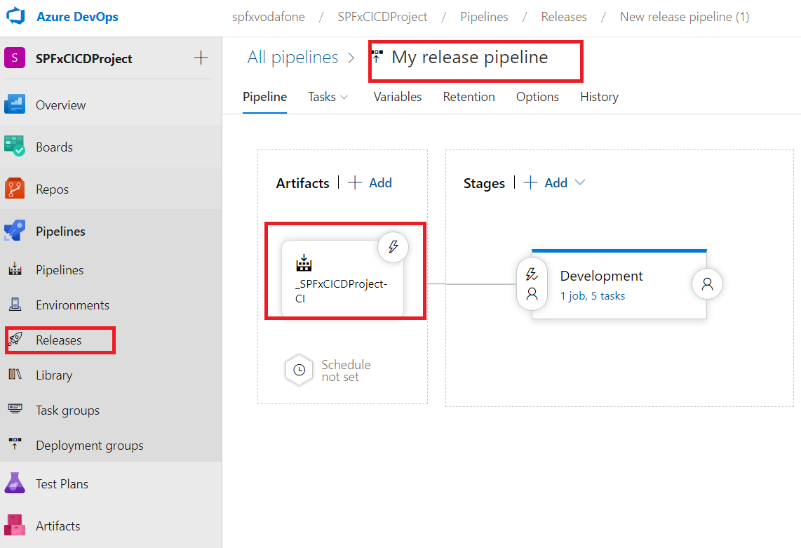

Add Node

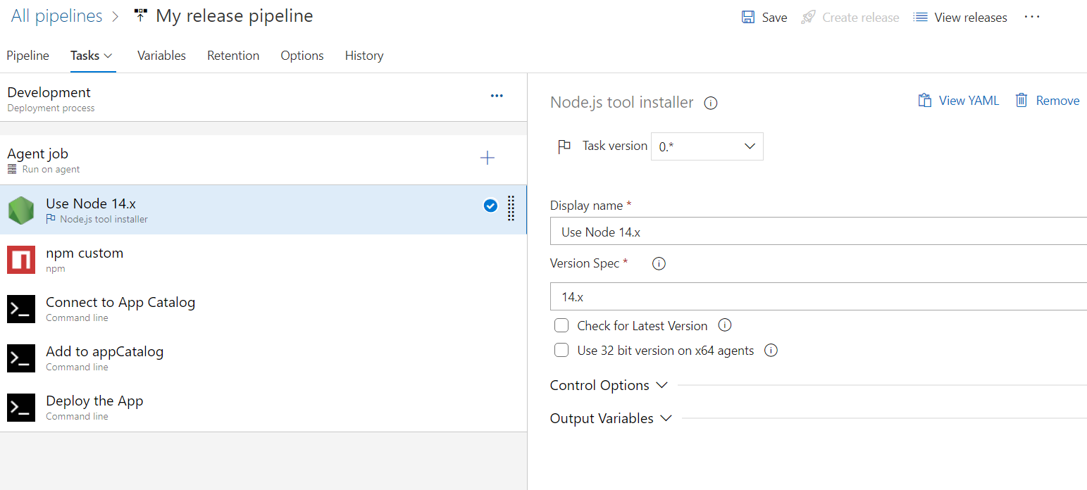

Add/install Office 365 CLI

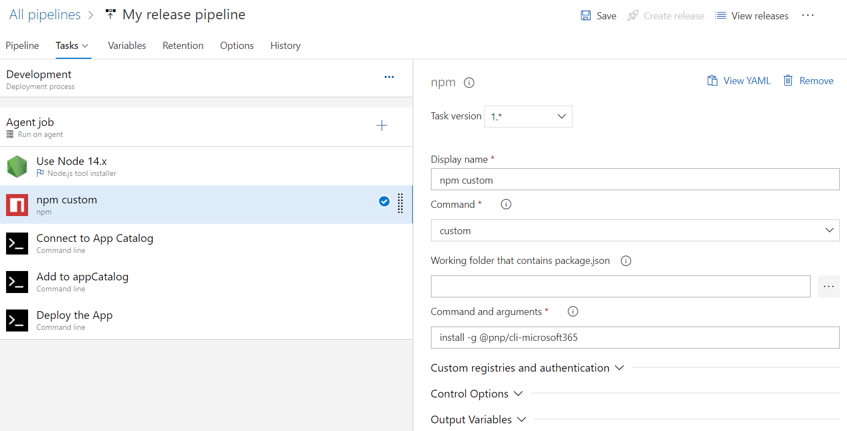

**Add command prompt**

Connect to App Catalog

m365 login https://spfxvodafone.sharepoint.com/sites/appcatalog --authType password --userName admin@spfxvodafone.onmicrosoft.com --password $(password)

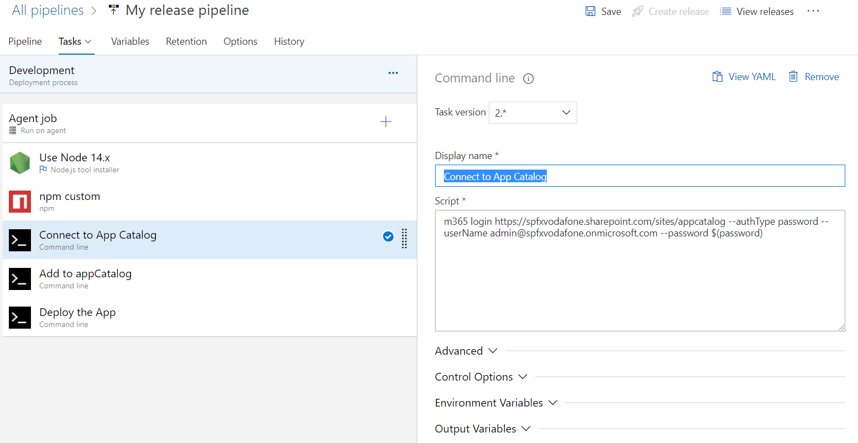

Add to App catalog

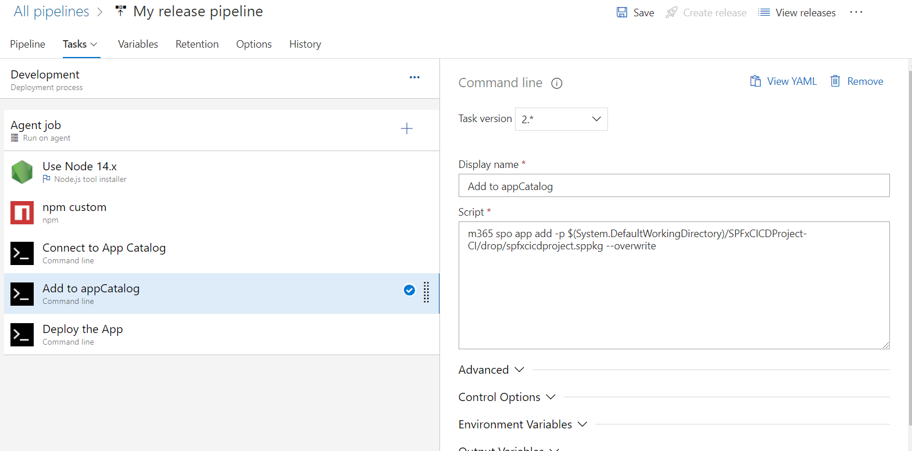

Deploy in App Catalog

